**WEEK 1**

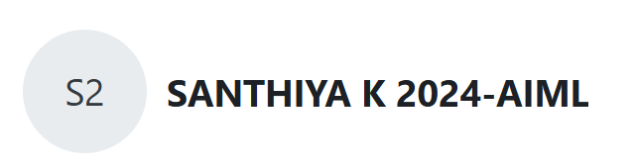

**Question 1:**

**The program must accept a positive integer N and print the digit in the tenth position.**

**Input Format:**

**The first line denotes the value of N.**

**Output Format:**

**The first line contains the value of N.**

**Program:**

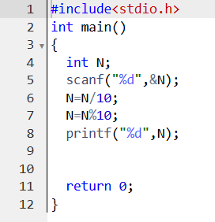

**Output:**

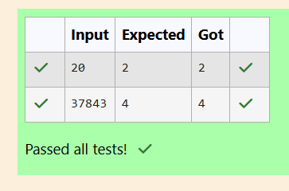

**Question 2:**

**Write a C Program to calculates the area (floating point number with two decimal places) of a circle given its radius (integer value). The value of Pi is 3.14.**

**Program:**

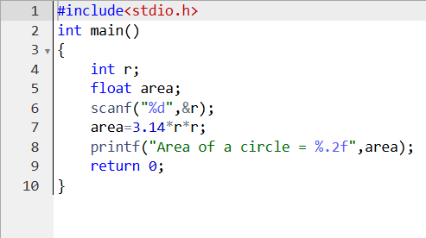

**Output:**

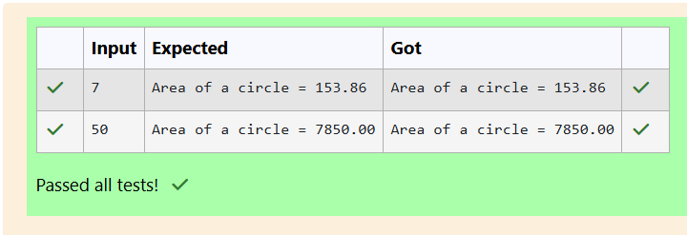

**Question 3:**

**Develop a 'C' program to swap two numbers (using three variables).**

**Program:**

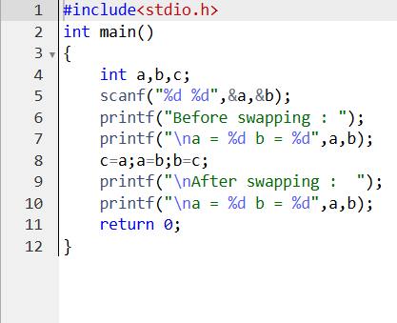

**Output:**

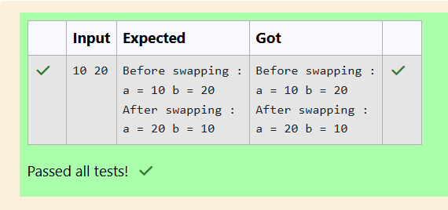

**Question 4:**

**Write a program to print the ASCII value of the given character.**

**Program:**

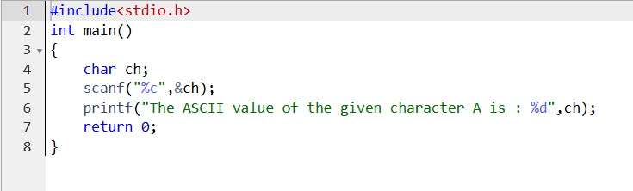

**Output:**

